Exponential Distribution

The **exponential distribution**describes the arrival time of a randomly recurring independent event sequence. If *μ*is the [mean](http://www.r-tutor.com/node/35) waiting time for the next event recurrence, its probability density function is:

      {
        1Î¼eâxâÎ¼    when x â¥ 0
f(x) =  0         when x < 0


Here is a graph of the exponential distribution with *μ*= 1.

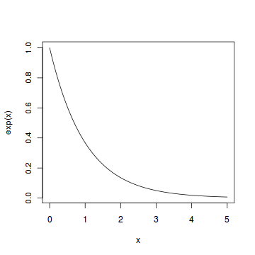

#### Problem

Suppose the mean checkout time of a supermarket cashier is three minutes. Find the probability of a customer checkout being completed by the cashier in less than two minutes.

#### Solution

The checkout processing rate is equals to one divided by the mean checkout completion time. Hence the processing rate is 1/3 checkouts per minute. We then apply the function pexp of the exponential distribution with rate=1/3.

> pexp(2, rate=1/3)   
[1] 0.48658

#### Answer

The probability of finishing a checkout in under two minutes by the cashier is 48.7%